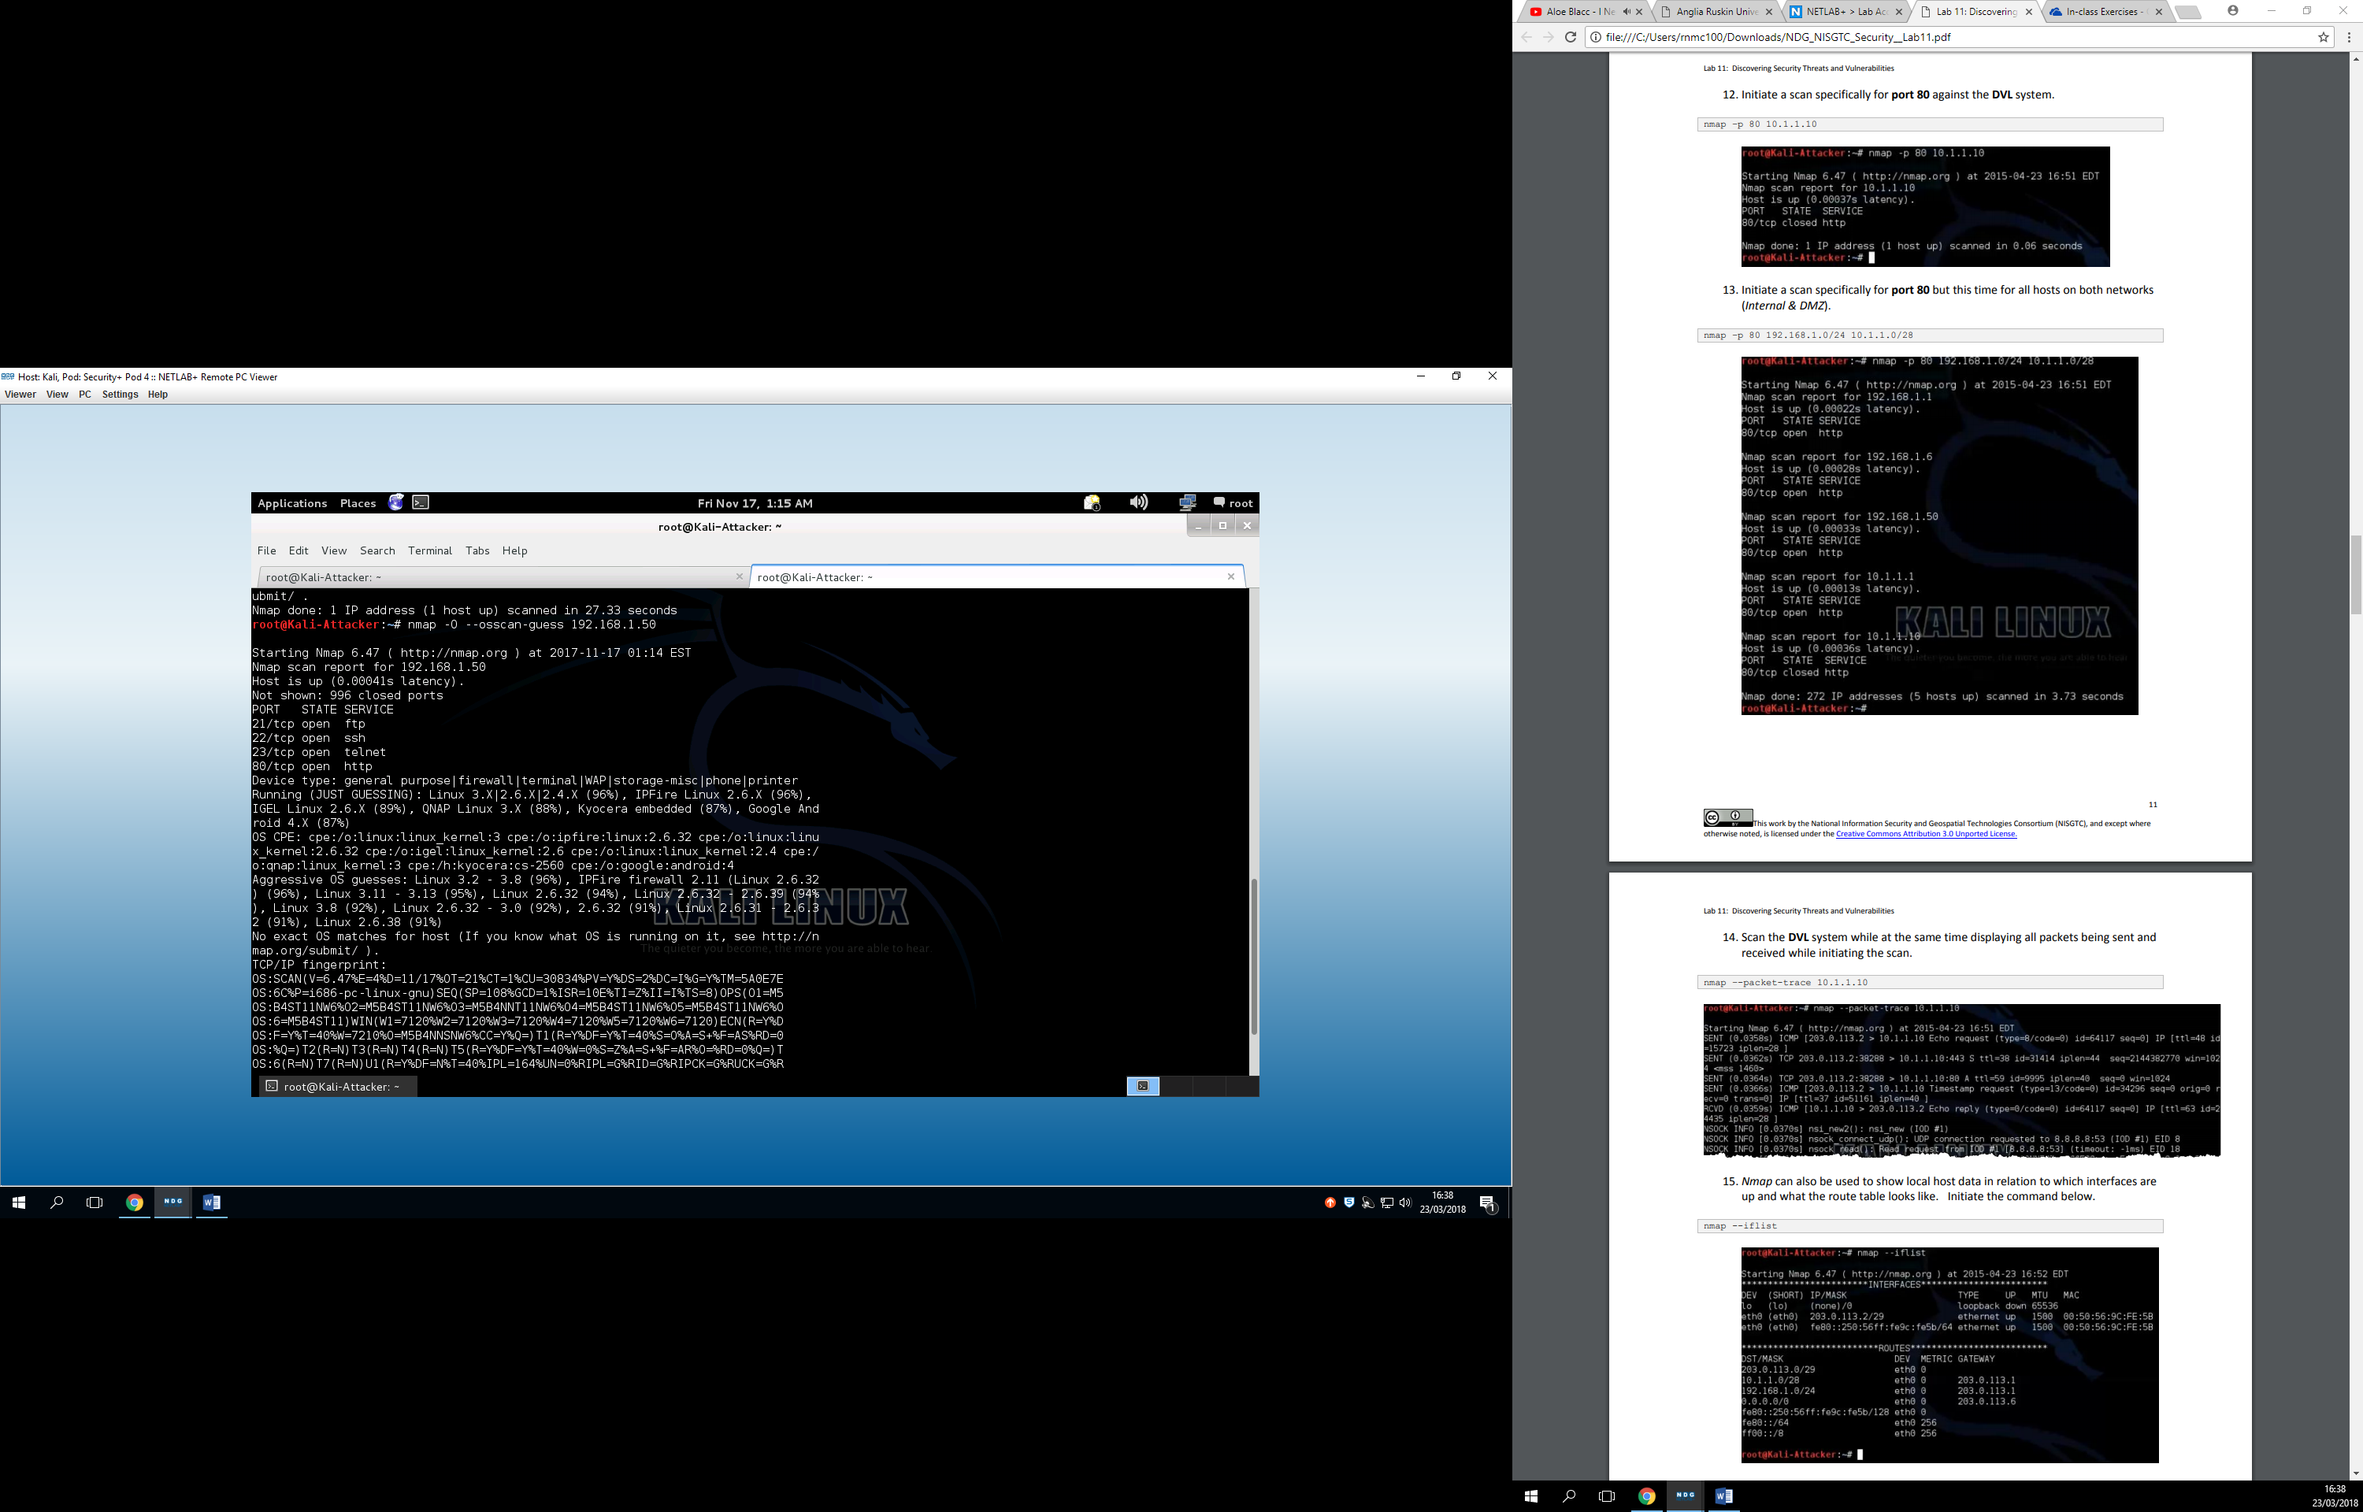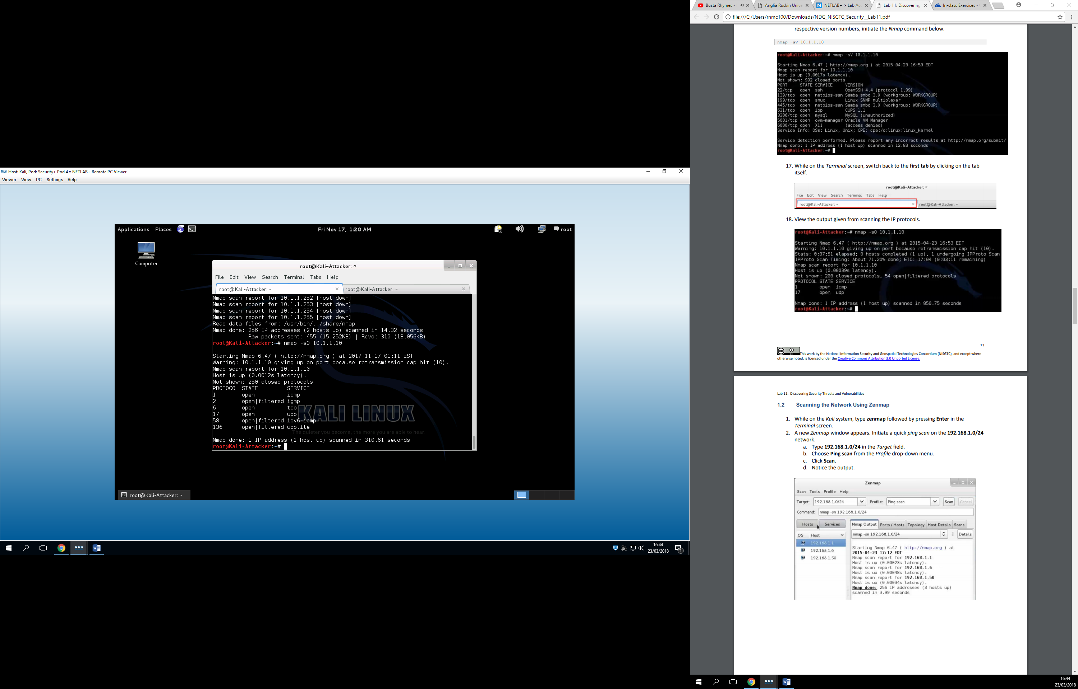

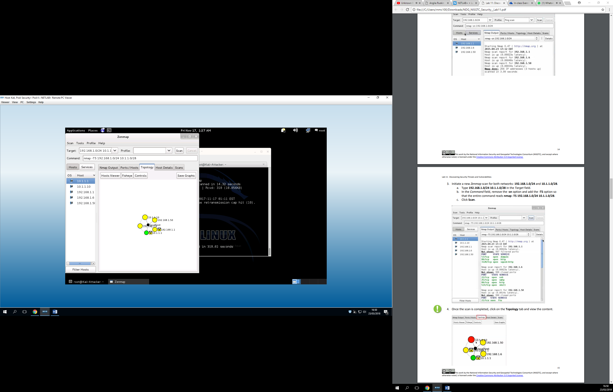

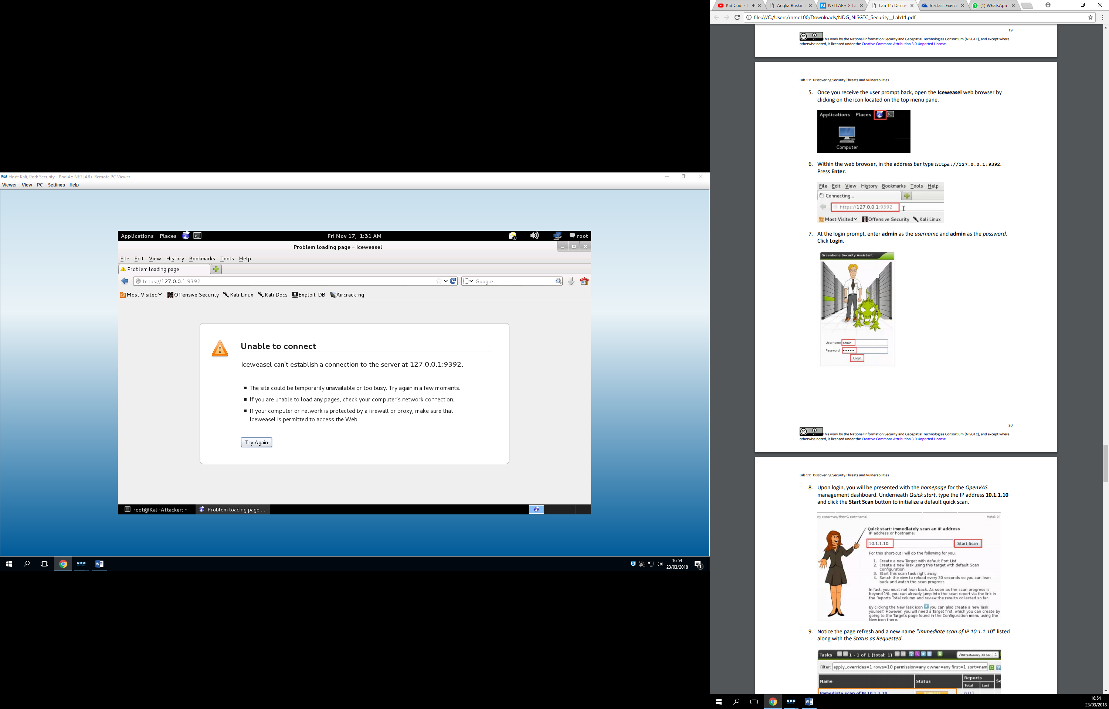

As I understood correctly, in this tutorial we are learning how to scan for threats and vulnerabilities through the command –nmap, which is basically a scan command. Throughout the tutorial we scan for multiple things, such as local hosts, live hosts on a certain network, etc…